
JULY SCHOOL



HOLIDAYS 2026

Monday 6th | Tuesday 7th | Wednesday 8th | Thursday 9th | Friday 10th
COOKING FUN    Learn to measure, mix and bake delicious snacks and lunch. | PAMPER DAY  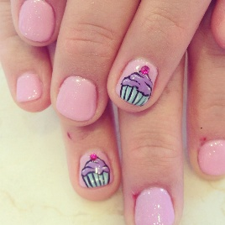  Feel relaxed and refreshed with a little skin care and nail art. | MUSICAL GAMES  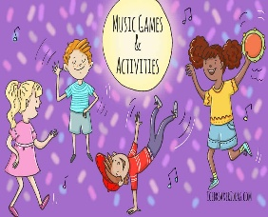  Developing our social skills while having fun playing games to music. | PYJAMA/MOVIE DAY  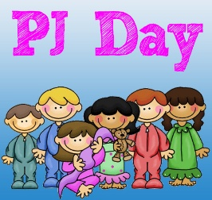  Chill out in PJ’s and watch movies. | MUNDARING SCULPTURE PARK  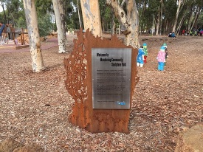  Have fun swinging, climbing and flying whilst increasing our social skills and gross motor skills.
Monday 13th | Tuesday 14th | Wednesday 15th | Thursday 16th | Friday 17th
SLIME DAY  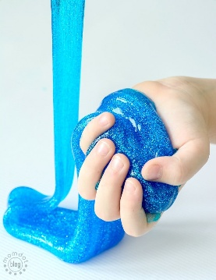  Learn how mixing different ingredients together react and create fun slime. | FIRST RESPONDERS  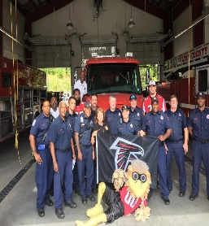  This Photo by Unknown Author is licensed under CC BY-NC-ND  Celebrate all of our first responders and investigate what they do. | READING CINEMAS    Watch a fun movie while practicing our social skills. | MINION CLAY DAY    Make our own Minion characters using clay while expanding our creativity and fine motor skills. | BASKETBALL ATHLETICS    Enjoy playing basketball with our friends and a little friendly competition.



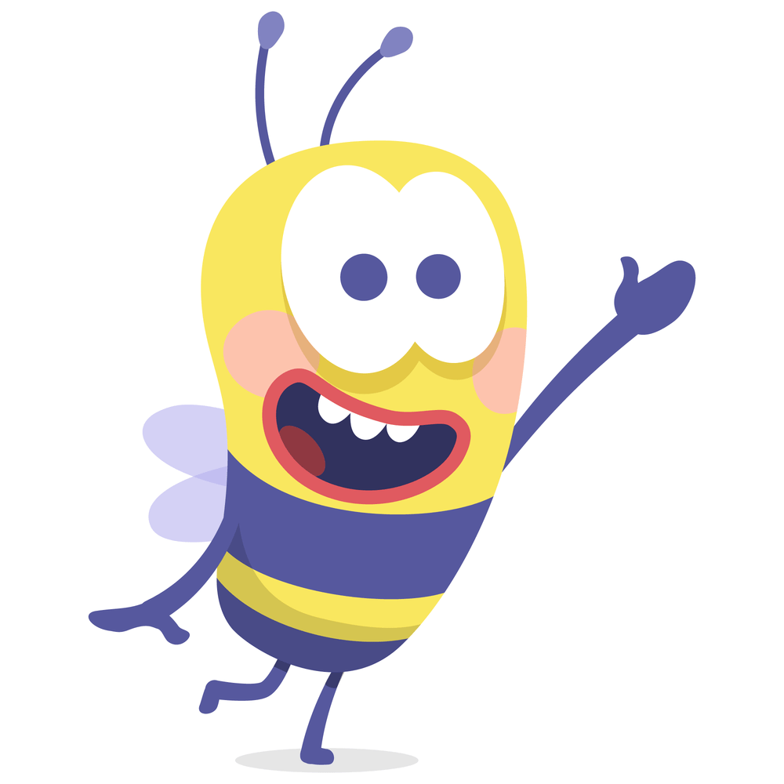
= Excursion
= Incursion

*Please aim to arrive at the centre
by 9am on excursion days*

= CLOSED

