APRIL HOLIDAY PROGRAM
10TH APRIL TO 26TH APRIL 2023
MONDAY 10TH | TUESDAY 11TH | WEDNESDAY 12TH | THURSDAY 13TH | FRIDAY 14TH
EASTER MONDAY PUBLIC HOLIDAY | CRAFT DAY BEADING  HAVE FUN MAKING OUR OWN DESIGNS | ACE CINEMA  THE SUPER MARIO BROS. MOVIE | DANCE/GYMNASTICS CLASSES | WONGIN PARK HENLEY BROOK  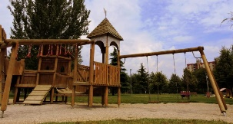
MONDAY 17TH | TUESDAY 18TH | WEDNESDAY 19TH | THURSDAY 20TH | FRIDAY 21ST
MAGIC SHOW DAY | MUNDARING SCULPTURE PARK  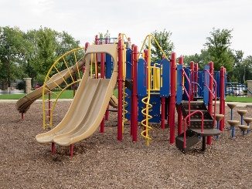 | GLOW IN THE DARK DAY  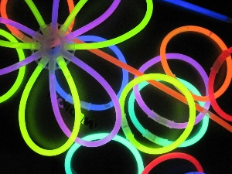 | KARAOKE DAY  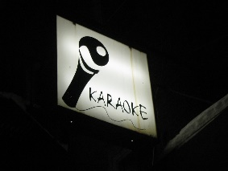 | ZONE BOWLING  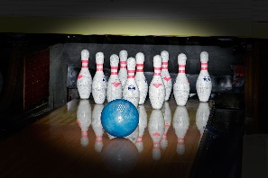
MONDAY 24TH | TUESDAY 25TH | WEDNESDAY 26TH
ANZAC DAY ACTIVITIES | ANZAC DAY PUBLIC HOLIDAY | BACK TO SCHOOL

